Project Design Phase-II

Data Flow Diagram & User Stories

|  |  |
| --- | --- |
| Date | 08 October 2022 |
| Team ID | PNT2022TMID44095 |
| Project Name | Smart Farmer - IOT Enabled Smart Farming  Application |
| Maximum Marks | 4 Marks |

# Data Flow Diagrams:

A Data Flow Diagram (DFD) is a traditional visual representation of the information flows within a system. A neat and clear DFD can depict the right amount of the system requirement graphically. It shows how data enters and leaves the system, what changes the information, and where data is stored.

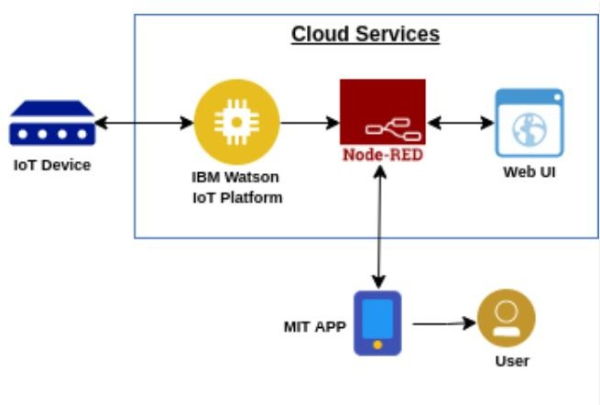

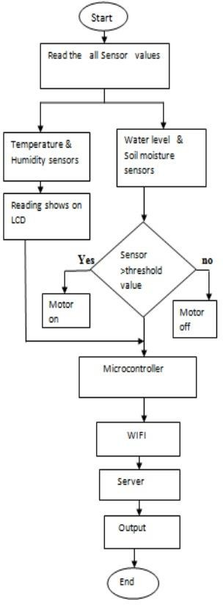

# User Stories

|  |  |  |  |  |  |
| --- | --- | --- | --- | --- | --- |
| **User Type** | **Functional**  **Requirement (Epic)** | **User Story Number** | **Users** email, password, and confirming my **password / Task** | **Acceptance criteria** | **Priority** |
| Customer (Mobile user) | Download the database | USN-1 | As a user, I can register for the application by entering my email, mobile, password and conforming my password | I can access my account / dashboard | High |
|  | Acknowledgement | USN-2 | As a user, I will receive confirmation email  once I have registered for the application | I can receive confirmation  email & click confirm | High |
|  | Register | USN-3 | As a user, I can register for the application through email, password and conforming the  password | I can register & access the dashboard with facebook Login | Low |
|  | Login | USN-4 | As a user, I can log into the application by entering email & password | I can login by using the credintials which I used above  while registering. | High |
|  | Dashboard | USN-5 | As a user, I can open the dashboard and monitor the activity in the farm land | I can login by using the credintials | High |
| Customer (Web user) | The functional requirements are same  as mobile user | USN-6 | Web user provides the user friendly platform to access and monitor the functionalities in the farm | I can login by using the credentials | High |
| Customer Care Executive | The functional  requirements are user friendly. | USN-7 | As a user, if we face any technical issue we can receive the details and can log to monitor the farm | I can login by any device | Low |